Artificial Intelligence Lab

Lab Manual 10



Department of Cyber Security

HITEC University Taxila

1. Introduction
Machine Learning (ML) is a subset of artificial intelligence that focuses on building systems that can learn from data and make decisions or predictions. This lab manual is designed to introduce students to foundational ML concepts through hands-on implementation of linear and logistic regression using Python and Scikit-learn.

2. Objectives
- Understand the concept of regression in AI
- Understand core machine learning techniques such as regression and classification.
- Implement linear and logistic regression models.
Software
- Python, Pycharm or VS-Code IDE

3. Theory
Linear and logistic regression are supervised learning algorithms used in statistical modelling, but serve different purposes. Linear regression predicts a continuous outcome variable, while logistic regression predicts a categorical (typically binary) outcome variable.

3.1 What is Regression?
Regression is a statistical technique to understand the relationship between a dependent variable and one or more independent variables. It helps determine the strength and nature of this relationship, enabling predictions and insights into how changes in the independent variables impact the dependent variable. Different types of regression exist, each suitable for different data and research objectives. The core goal is to model the relationship between variables, often to predict future outcomes or understand underlying patterns.
Types of Regression
- Linear Regression
- Logistic Regression

3.2 Linear Regression
Linear regression is a predictive analytics method that uses a mathematical formula to generate predictions. It's valued for its interpretability, making it easy to understand how input variables influence the outcome. It models the relationship between a dependent variable and one or more independent variables by fitting a linear equation to observed data. The goal is to find the 'best fit' line that minimizes the differences between the predicted and actual values. This is a foundational concept in statistics and machine learning used for forecasting and understanding relationships within datasets.
- Purpose: Predicts a continuous numerical value based on one or more input variables.
- Example: Predicting house prices based on square feet and other factors.
- Output: A continuous number, like the predicted house price.
- Relationship: Assumes a linear relationship between the input(independent) and output(dependent) variables.
- Equation: y = mx + b (simple linear regression) or (multiple linear regression).
- Types of Linear Regression
- Simple Linear Regression:
Models a relationship between one independent and one dependent variable, assuming a linear relationship.
- Multiple Linear Regression:
Extends simple linear regression by including multiple independent variables.
- Polynomial Regression:
Models’ relationships that are not linear by fitting a polynomial curve to the data.

Linear Regression with One Variable

Sample problem of predicting home prices in the USA
The table below represents current home prices in the USA based on square feet.
Problem Statement: Given the above data, build a machine learning model that can predict home prices based on square feet area
You can represent values in the above table as a scatter plot (shown in red markers). After that, one can draw a straight line that best fits the values on the chart.
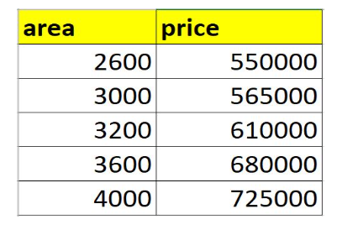
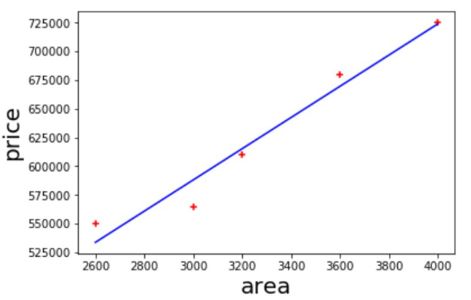
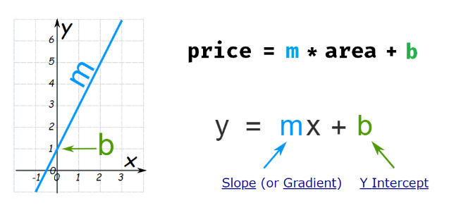

3.4 Implementation in Python
import pandas as pd
from sklearn import linear_model
import matplotlib.pyplot as plt
# Creating a simple dataset
data = {'Area': [500, 1000, 1500, 2000, 2500],
'Price': [150000, 200000, 250000, 300000, 350000]}
# Convert to DataFrame
df = pd.DataFrame(data)
# Plotting the data
plt.xlabel('Area')
plt.ylabel('Price')
plt.scatter(df['Area'], df['Price'], color='red', marker='+')
plt.show()
# Create linear regression object
reg = linear_model.LinearRegression()
# Use df[['Area']] (2D) and df['Price'] (1D)
reg.fit(df[['Area']], df['Price'])
# Predict price of a home with area = 3300 sq ft
predicted_price = reg.predict([[3300]])
print("Predicted price for 3300 sq ft:", predicted_price)
# y=mx+b
# Print the slope (coefficient) and intercept of the line
print("Coefficient (slope):", reg.coef_)
print("Intercept:", reg.intercept_)
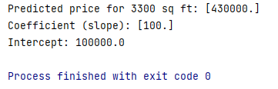
3.5 Logistic Regression
Logistic regression is a supervised machine learning algorithm primarily used for classification tasks. It predicts the probability of a binary outcome (e.g., yes/no, true/false). The algorithm uses a logistic function (sigmoid) to map the linear combination of input features to a probability value between 0 and 1. This allows it to classify data points into different categories based on the predicted probability. Although primarily for binary classification, it can be extended to handle multi-class problems.
- Purpose: Predicts the probability of a categorical outcome (typically a binary outcome, like yes/no, true/false).
- Example: Predicting whether an email is spam or not.
- Output: A probability value between 0 and 1, representing the likelihood of the event occurring.
- Relationship: Uses a logistic function (sigmoid function) to map the input variables to a probability.
Sigmoid Function:
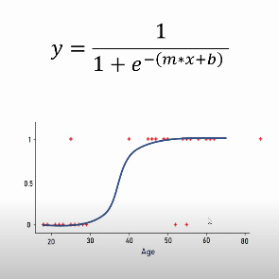
The sigmoid function is a mathematical function that maps any real-valued number into the range (0, 1). Its formula is:
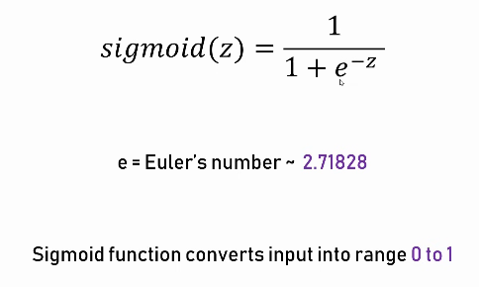
Where:
- z = w x + b (i.e., the linear combination of inputs and model parameters)
- e is the base of the natural logarithm.
Why is the Sigmoid Function Used in Logistic Regression?
- In linear regression, the output is a continuous value (e.g., house price).
- But in logistic regression, we want to classify into discrete classes (e.g., pass/fail → 0 or 1).
- The sigmoid function squashes the output of the linear equation into a probability value between 0 and 1.
- If σ(z)>0.5, we classify the output as 1; otherwise, 0.
- You don’t write the sigmoid manually when using LogisticRegression() in scikit-learn.
- It is used internally by the model when you call fit () and. predict ().

3.5 Implementation in Python
# Import necessary libraries
import pandas as pd
from sklearn.model_selection import train_test_split
from sklearn.linear_model import LogisticRegression
import matplotlib.pyplot as plt

# Creating a simple dataset
data = {'Hours': [1, 2, 3, 4, 5, 6, 7, 8],
'Result': [0, 0, 0, 0, 1, 1, 1, 1]}

# Convert to DataFrame
df = pd.DataFrame(data)

# Visualize the data
plt.xlabel('Hours Studied')
plt.ylabel('Pass/Fail')
plt.scatter(df['Hours'], df['Result'], color='blue', marker='o')
plt.show()

# Split the data into training and testing sets
X_train, X_test, y_train, y_test = train_test_split(df[['Hours']], df['Result'], test_size=0.25)

# Create logistic regression model
model = LogisticRegression()

# Train the model
model.fit(X_train, y_train)

# Predict result for a new input
new_prediction = model.predict([[4.5]])
print("Prediction for 4.5 hours studied:", new_prediction)

Output:
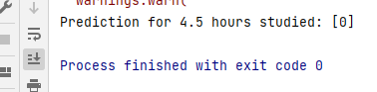

4. Lab Task
- Predict Canada's per capita income in the year 2020 using the canada_per_capita_income.csv file. Using this, build a regression model and predict the per capita income of Canadian citizens in the year 2020.
Here is the link to the CSV file: https://drive.google.com/file/d/1mhtt-55J4kyZeIMY4EJpUV7ul3hXYEPw/view?usp=sharing

- Using the below dataset, build a logistic regression model to predict whether a customer will purchase a product or not (Purchased) based on the features Age, Gender, Annual_Income, and Browsing_Time. Perform the following tasks:
- Preprocess the data (e.g., convert Gender to numerical).
- Split the data into features (X) and target (y).
- Fit a logistic regression model using scikit-learn.
- Predict the purchase status for the new sample data.
- Evaluate the model using the accuracy score.

CustomerID | Age | Gender | Annual_Income (k$) | Browsing_Time (min) | Purchased (1=Yes, 0=No)
1 | 25 | Male | 35 | 10 | 0
2 | 34 | Female | 60 | 25 | 1
3 | 45 | Male | 80 | 5 | 0
4 | 23 | Female | 40 | 30 | 1
5 | 31 | Male | 50 | 20 | 1
6 | 29 | Female | 45 | 15 | 0
7 | 38 | Male | 75 | 12 | 1
8 | 41 | Female | 90 | 5 | 0
9 | 27 | Male | 30 | 40 | 1
10 | 36 | Female | 65 | 22 | 1

5. Conclusion

